May 12th June 9th July 14 (double-points) September 8th
Judge: Vicky Cole Judge: Lisa Brunner Judge: TBA Judge: Michelle Nyberg

Rain or shine • Indoor-80x200 • Outdoor-100x220 • Warm-up 7am-8:45am • Show starts at 9am sharp

Great Prizes and Paybacks at every show $8.00 per class 5.00 grounds/office fee
All group B’s-12 and under
9am - All Western Classes 24. Novice Rider Pleasure W/J 41. Beginner Dash
1. Open Halter 25. Novice Rider Equitation W/J 42. Jog/Trot dash
2. Open Showmanship 26. Novice Rider Command W/J 43. Open Stake in Barrel
3. Jr. Halter (17yrs & younger) 27. Ranch Riding 44. Adult Stake in Barrel
4. Jr. Showmanship 28. Ranch Horse Trail 45. Jr. Stake in Barrel
5. Adult Halter (18yrs & older) 46. Youth Figure 8
5. Adult Halter (18yrs & older) 47. Pee Wee Figure 8
6. Adult Showmanship 48. Beginner Figure 8
7. Leadline-Suitability LUNCH/SCHOOLING BREAK 49. Jog/Trot Figure 8
8. Leadline-Equitation 50% payback or ribbons in gaming 50. Open keyhole
9. Leadline-Trail Not before 12- all gaming classes 51. Adult Keyhole
10. Ranch Horse Conformation 52. Jr. Keyhole
11. In Hand Trail Exhibition Run $5.00 per run 53. Youth Keyhole
12. Green Horse Pleasure W/J 54. Pee Wee Keyhole
13. Green Horse Equitation W/J 29. Open Cloverleaf 55. Beginner Keyhole
Payback 30. Adult Cloverleaf (19yrs & older) 56. Jog/Trot Keyhole
14. Green Horse Command W/J 31. Jr. Cloverleaf (15yrs - 18yrs) 57. Open Pole Bending
15. Open Pleasure 32. Youth Cloverleaf (11yrs - 14yrs) 58. Adult Pole Bending
16. Open Equitation-Payback 33. Pee Wee Cloverleaf (10yrs & younger) 59. Jr. Pole Bending
17. Open Horsemanship 34. Beginner Cloverleaf 60. Youth Pole Bending
18. Jr. Pleasure 35. Jog/Trot Cloverleaf 61. Peewee Pole Bending
19. Jr. Equitation-Payback 36. Open Dash 62. Beginner Pole Bending
20. Jr. Horsemanship 37. Adult Dash 63. Jog/Trot Pole Bending
21. Adult Pleasure 38. Jr. Dash
22. Adult Equitation-Payback 39. Youth Dash
23. Adult Road Hack 40. Pee Wee Dash

• Stalls available at $20 a day • All horses must have current coggins’

• Oriskany Creek Farm will not be responsible for any loss, injury or damage to horse, rider, spectators or equipment brought to the show

• All riders are at their own risk • All dogs must be on a leash • Judge’s decision will be final • Year-end high point lead line
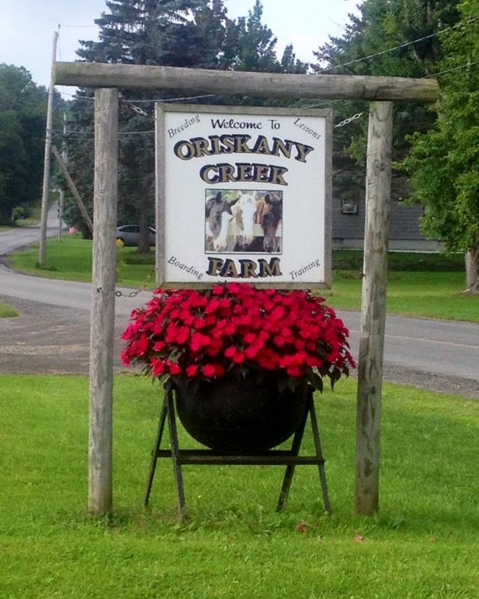
Electronic Timer * Champion & Reserve
Must compete in 3 of 4 shows to be eligible for
Year-End Awards

10
TACK FOR SALE AT ALL SHOWS
~ VENDORS WELCOME ~

Oriskany Creek Farm
7580 Old Bristol Rd, Clinton New York 13323
Phone: 315-838-8770
Year-End Awards: October 13th @12-noon

We are offering class sponsorships

