June 14th July 12th September 13th
Judge: Jennifer Woodruff Judge: Heather Blehar-Moore Judge: Lisa Eklund

Rain or Shine * Indoor - 80 x 200 * Outdoor – 100 x 220 • Warm-up 7am-8:45am * Show starts at 9am sharp

Great Prizes + Paybacks at every show $10.00 per class $10.00 grounds/office fee

1. Hopeful Hunter O/F 2’ LUNCH 40. Beginner Hunter O/F Verticals
2. Hopeful Hunter O/F 2’ 23. Leadline Equitation 41. Beginner Hunter Equitation O/F
3. Hopeful Hunter U/S 24. Leadline Suitability 42. Beginner Hunter U/S
4. Hopeful Hunter Pleasure 25. Leadline Poles 43. Beginner Hunter Equitation
44. Beginner Hunter Pleasure
5. Novice Rider O/F 2’ 26. Walk/Trot Ground Poles
6. Novice Rider Equitation O/F 2’ 27. Walk/Trot Equitation Ground Poles
7. Novice Rider U/S 28. Walk/Trot Ground Poles U/S
Large classes will be spit A’s & B’s
To be eligible for year- end awards you must complete 2 out of 3 shows
Champion and Reserve given in each division
6 Ribbons per class at $10.00 per class
Year-End High Point Lead Line
8. Novice Rider Equitation 29. Walk/Trot Ground Poles Pleasure
9. Novice Rider Pleasure 30. Walk/Trot X-Rails
31. Walk/Trot Equitation X-Rails
10. Low + Slow Hunter O/F 2’3’’ 32. Walk/Trot Hunter U/S
11. Low + Slow Hunter O/F 2’3’’ 33. Walk/Trot Equitation
12. Low + Slow Hunter U/S
13. Low + Slow Pleasure 34. Walk/Trot Pleasure
SCHOOLING BREAK - 10 Minutes

14. Open Hunter O/F 2’3’’ 35. Short/Long Stirrups X-Rails
15. Open Hunter Equitation O/F 2’3’’ 36. Short/Long Equitation X-Rails
16. Open Hunter U/S 37. Short/Long Hunter U/S
17. Open Hunter Equitation 38. Short/Long Equitation
18. Open Hunter Pleasure 39. Short/Long Pleasure

19. Classic Hunter O/F 2’6’’ SCHOOLING BREAK 10- Minutes
20. Classic Hunter O/F 2’6’’
21. Classic Hunter U/S
22. Classic Hunter Bridle Path Hack

• Stalls available at $20 a day • All horses must have current coggins’

• Oriskany Creek Farm will not be responsible for any loss, injury or damage to horse, rider, spectators or equipment brought to the show

• All riders are at their own risk • All dogs must be on a leash • Judge’s decision will be final
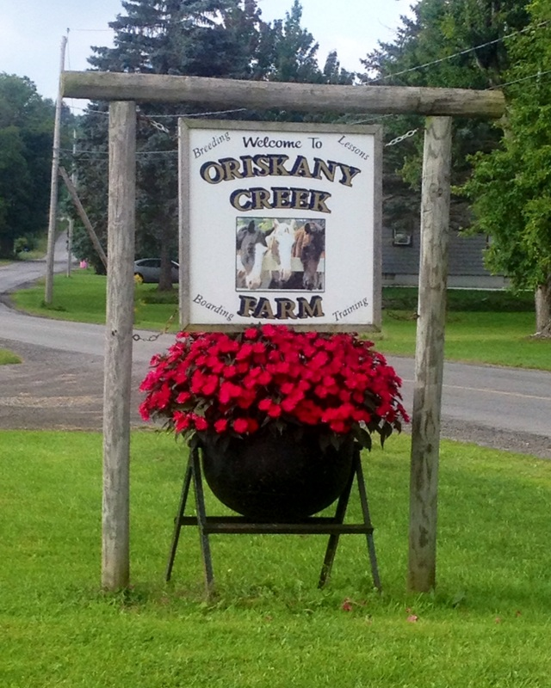
TACK FOR SALE AT ALL SHOWS
~ VENDORS WELCOME ~

We are offering class sponsorships

Year-End Awards: October 11 @ 12-noon

Oriskany Creek Farm
7580 Old Bristol Rd, Clinton New York 13323
Phone: 315-838-8770

