June 21st July 19th (double point) September 20th
Judge: Chrissy Southwick Judge: Lisa Brunner Judge: Jennifer Woodruff

Rain or shine • Indoor-80x200 • Outdoor-100x220 • Warm-up 7am-8:45am • Show starts at 9am sharp

Great Prizes and Paybacks at every show $10.00 per class $10.00 grounds/office fee
All group B’s-12 and under
9am - All Western Classes 25. Open Equitation 46. Pee Wee Figure 8
1. Mini / Pony Halter 26. Open Horsemanship 47. Beginner Figure 8
2. Mini / Pony Showmanship 27. Trail Class 48. Jog/Trot Figure 8 (A+B)
3. Adult Halter (18yrs and older) LUNCH/SCHOOLING BREAK 49. Open keyhole
4. Adult Showmanship 50% payback or ribbons in gaming 50. Adult Keyhole
5. Open Halter Not before 12- all gaming classes 51. Jr. Keyhole
6. Open Showmanship 52. Youth Keyhole
7. Jr. Halter Exhibition Run $5.00 per run 53. Pee Wee Keyhole
8. Jr. Showmanship 28. Open Cloverleaf 54. Beginner Keyhole
9. In Hand Trial 29. Adult Cloverleaf (19yrs & older) 55. Jog/Trot Keyhole (A+B)
10. Leadline - Suitability 30. Jr. Cloverleaf (15yrs - 18yrs) 56. Open Pole Bending
11. Leadline – Equitation 31. Youth Cloverleaf (11yrs - 14yrs) 57. Adult Pole Bending
12. Leadline – Trail 32. Pee Wee Cloverleaf (10yrs & younger) 58. Jr. Pole Bending
13. Green Horse Pleasure W/J 33. Beginner Cloverleaf 59. Youth Pole Bending
14. Green Horse Equitation W/J 34. Jog/Trot Cloverleaf (A+B) 60. Peewee Pole Bending
35. Open Dash 61. Beginner Pole Bending
15. Green Horse Command W/J 36. Adult Dash 62. Jog/Trot Pole Bending (A+B)
16. Mini / Pony – Pleasure Driving 37. Jr. Dash
17. Mini / Pony – Farm class 38. Youth Dash
18. Adult Pleasure 39. Pee Wee Dash
19. Adult Equitation 40. Beginner Dash
20. Adult Road Hack 41. Jog/Trot dash (A+B)
21. Jr. Pleasure 42. Open Figure 8
22. Jr. Equitation 43. Adult Figure 8
23. Jr. Horsemanship 44. Jr. Figure 8
24. Open Pleasure 45. Youth Figure 8

• Stalls available at $20 a day • All horses must have current coggins’

• Oriskany Creek Farm will not be responsible for any loss, injury or damage to horse, rider, spectators or equipment brought to the show

• All riders are at their own risk • All dogs must be on a leash • Judge’s decision will be final • Year-end high point lead line
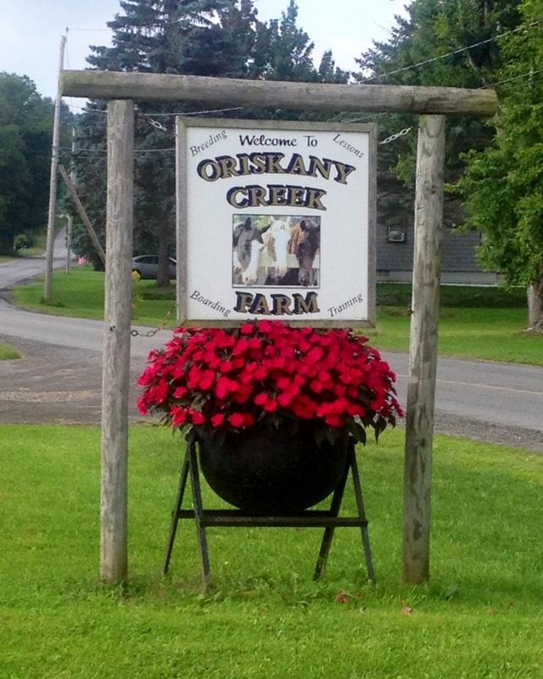
Electronic Timer * Champion & Reserve
Must compete in 2 of 3 shows to be eligible for
Year-End Awards

10
TACK FOR SALE AT ALL SHOWS
~ VENDORS WELCOME ~

Oriskany Creek Farm
7580 Old Bristol Rd, Clinton New York 13323
Phone: 315-838-8770
Year-End Awards: October 11th @ 12-noon

We are offering class sponsorships

