May 19th June 16th July 21nd (double- points) September 15th
Judge: Marci Fuller Judge: Jennifer Mosher Judge: Lori Winters Hinman Judge: Chrissy Southwick

Rain or Shine * Indoor - 80 x 200 * Outdoor – 100 x 220 • Warm-up 7am-8:45 am * Show starts at 9am sharp

Great Prizes + Paybacks at every show $8.00 per class $5.00 grounds/office fee

1. Warm-up 2’ $6.00 23. Open Hunter Pleasure-Payback 41. Beginner Hunter O/F Verticals
2. Hopeful Hunter O/F 2’ 24. Classic Hunter O/F 2’6’’ 42. Beginner Hunter Equitation O/F
3. Hopeful Hunter O/F 2’ 25. Classic Hunter O/F 2’6’’ 43. Beginner Hunter U/S -
4. Hopeful Hunter U/S 26. Classic Hunter Bridle Path Hack 44. Beginner Hunter Equitation
45. Beginner Hunter Pleasure-
5. Hopeful Hunter Pleasure 27. Classic Hunter U/S Payback
6. Novice Rider Equitation O/F 2’ LUNCH
7. Novice Rider Hunter O/F 2’ 28. Leadline-Equitation
Large classes will be spit A’s & B’s
To be eligible for year- end awards you must complete 3 out of 4 shows
Champion and Reserve given in each division
6 Ribbons per class at $8.00 per class
Year-End High Point Lead Line
8. Novice Rider Equitation 29. Leadline - Suitability
9. Novice Rider U/S 30. Leadline - Poles
31. Walk/Trot X-Rails
10. Novice Rider Pleasure-Payback 32. Walk/Trot Equitation X-Rails
11. Pony Hunter O/F 2’ 33. Walk/Trot Hunter U/S
12. Pony Hunter O/F 2’
13. Pony Hunter U/S 34. Walk/Trot Equitation
35. Walk/Trot Pleasure
14. Pony Hunter Pleasure SCHOOLING BREAK - 10 Minutes
15. Low + Slow Hunter O/F 2’3’’ 36. Short/Long Stirrups X-Rails
16. Low + Slow Hunter O/F 2’3’’ 37. Short/Long Equitation X-Rails
17. Low + Slow Hunter U/S 38. Short/Long Hunter U/S
18. Low + Slow Hunter Pleasure 39. Short/Long Equitation
40. Short/Long Pleasure-Payback
19. Open Hunter Equitation O/F 2’3’’ SCHOOLING BREAK 10- Minutes
20. Open Hunter O/F 2’3’’
21. Open Hunter Equitation
22. Open Hunter U/S

• Stalls available at $20 a day • All horses must have current coggins’

• Oriskany Creek Farm will not be responsible for any loss, injury or damage to horse, rider, spectators or equipment brought to the show

• All riders are at their own risk • All dogs must be on a leash • Judge’s decision will be final
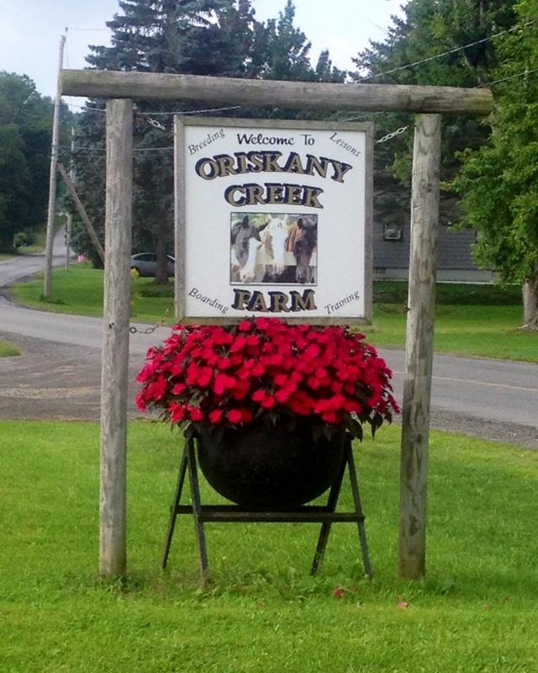
TACK FOR SALE AT ALL SHOWS
~ VENDORS WELCOME ~

We are offering class sponsorships

Year-EndAwards:October13th@12-noon
Oriskany Creek Farm
7580 Old Bristol Rd, Clinton New York 13323
Phone: 315-838-8770

